Assignment -1

Priyaben Pareshbhai Patel

8165235

User Interface Design Principles(PROG8150)

Professor David Hamilton

February 8, 2018

**Principles of user interface design**

1. Know your user:

Design user interface in such a way that user find it easy to learn.

Implementation: Providing hint in search bar, user find it easy to understand what is it.

Supporting Evidence:



1. Make Affordance:

Users can understand or know what actions they can perform.

Implementation: Providing graphical user interface (i.e. App icons itself shows what action user can perform through that app).

Supporting Evidence:



1. Map Functionality:

Map functionality means proper arrangement of relationship among items so, users can easily work in flow.

Implementation: popup menu by right clicking on desktop shows mapping in sort by option.

Supporting Evidence:

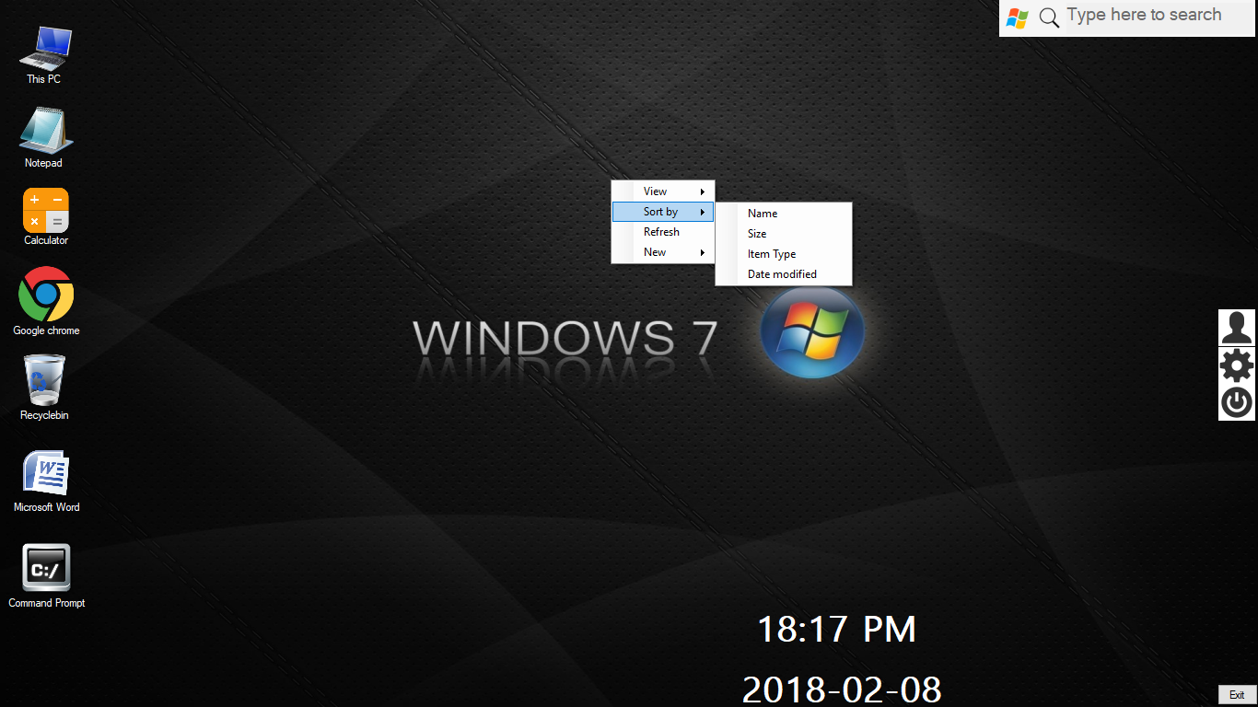

1. Feedback:

User gets information about what action he performed.

Implementation: If user moves folder to another folder it shows the action.

Supporting Evidence:

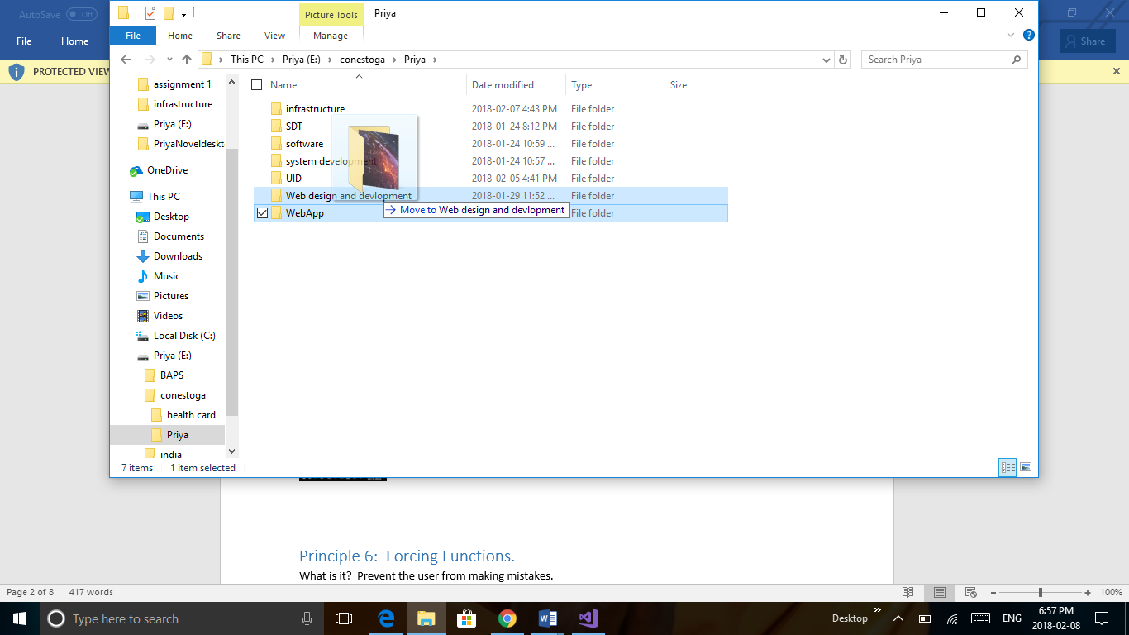

1. Use Metaphors:

Representing an action by providing things that are familiar to user.

Implementation: Graphical symbol for app icons.

Supporting Evidence:

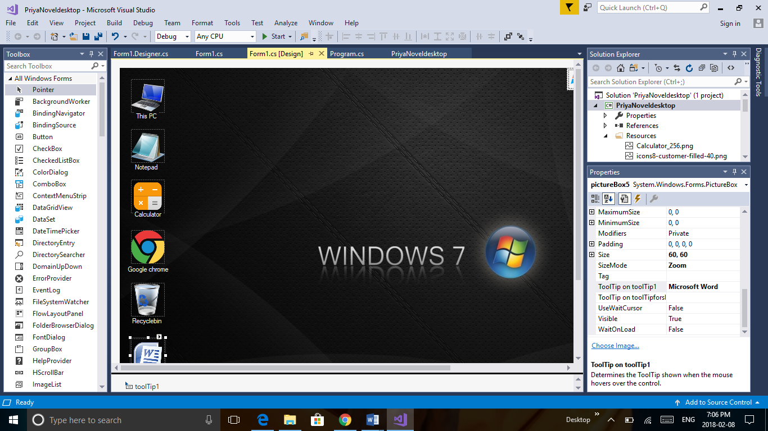

1. Forcing Functions:

It is an aspect of design that prevents the user from making errors.

Implementation: In notepad edit menu disables some actions to prevent mistakes.

Supporting Evidence:



1. Automatic Learning:

It helps the user to learn automatic by providing repetitive patterns.

Implementation: same type of action option for every file by right clicking on file.

Supporting Evidence:

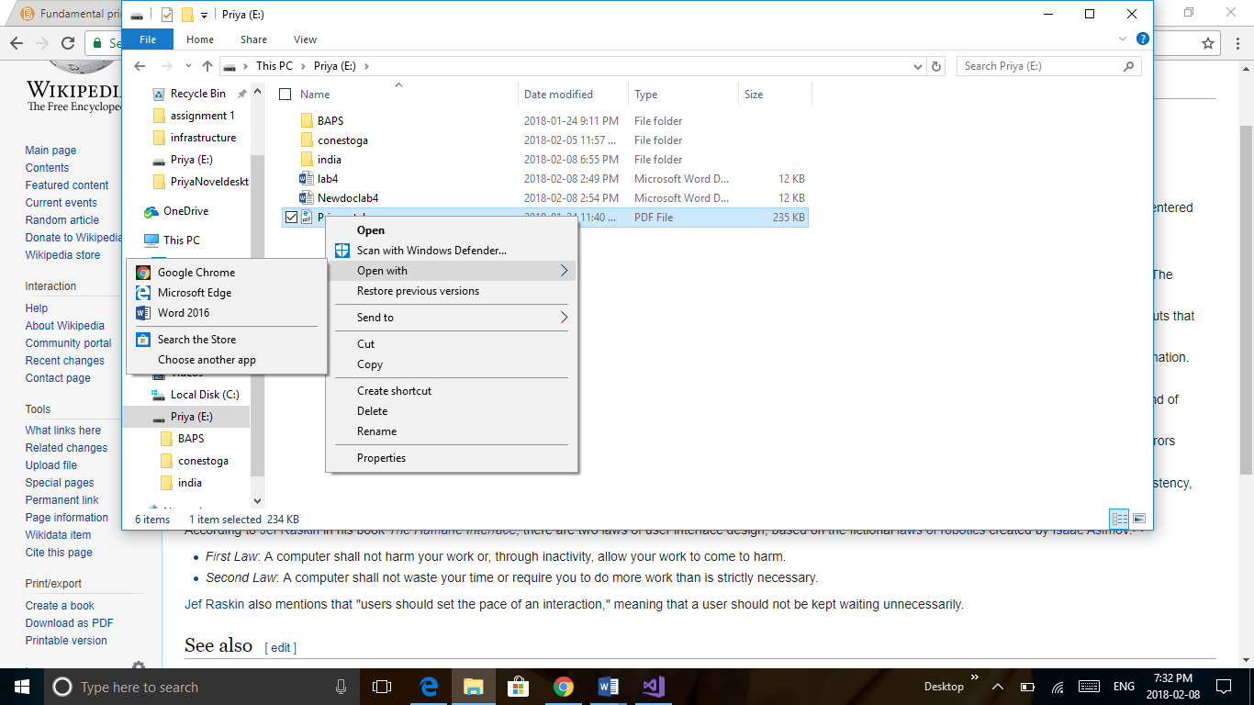

1. Context + Detail:

Provide enough details to the user of the task he is performing and keep him aware of where is he in the big picture.

Implementation: Progress bar shows how much work is done and how much remaining.

Supporting Evidence:



**User Interface Design Guidelines**

1. Don not use narrow, short or tall command buttons with text labels.

Supporting Evidence:

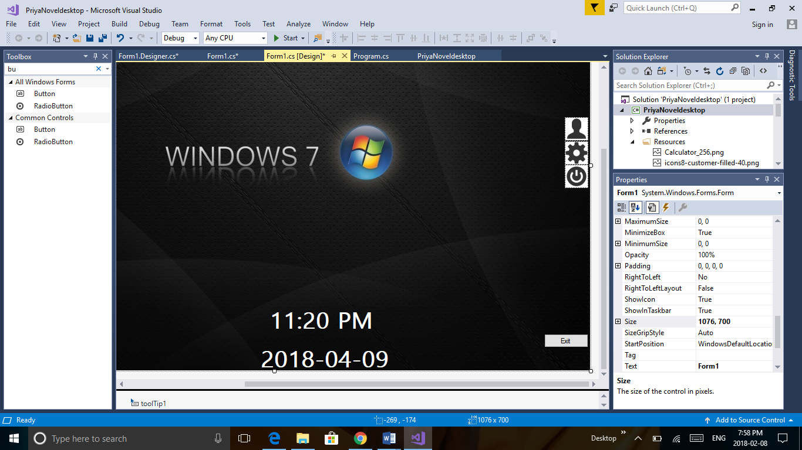

1. Provide tooltip for icons.

Supporting Evidence:



1. Describe the item concisely and list the primary tasks that users can perform with the icon.

Supporting Evidence:

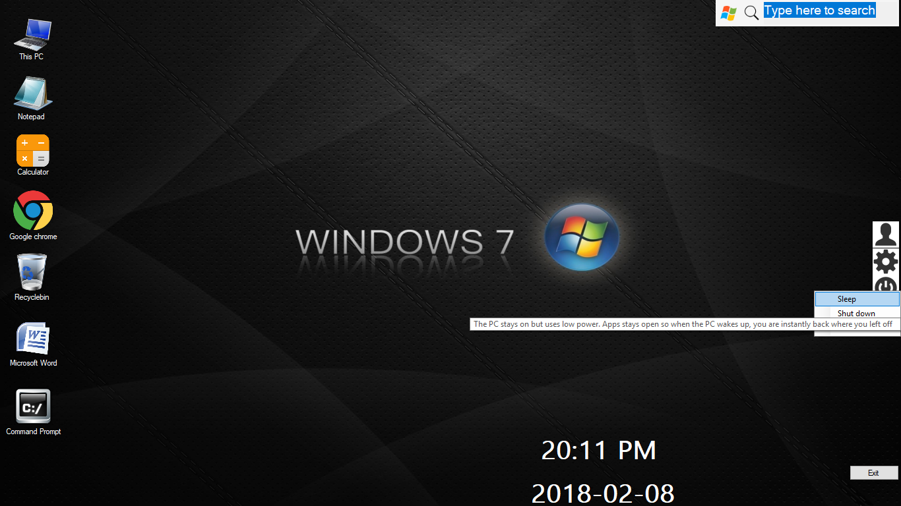

1. Use context menus only for contextual command and option

Supporting Evidence:



1. Menu items that display submenus that have an ellipsis on their label. The submenu arrow indicates that another selection is required.

Supporting Evidence:

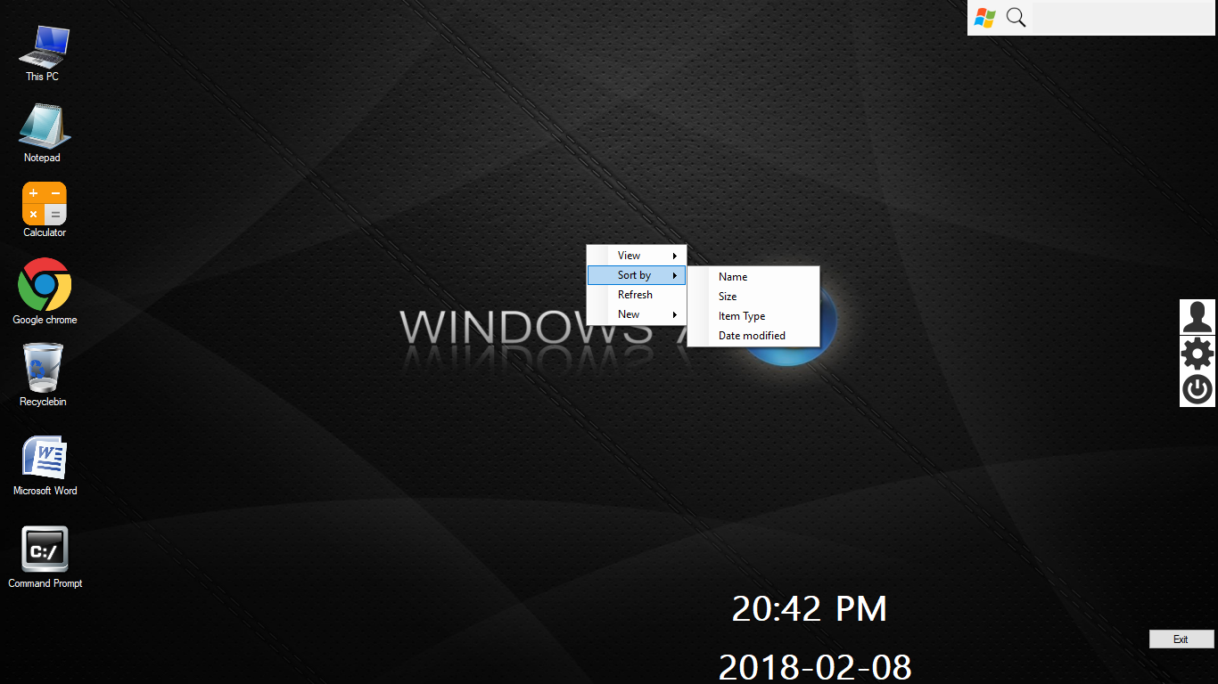

1. Document all shortcut keys.

Supporting Evidence:

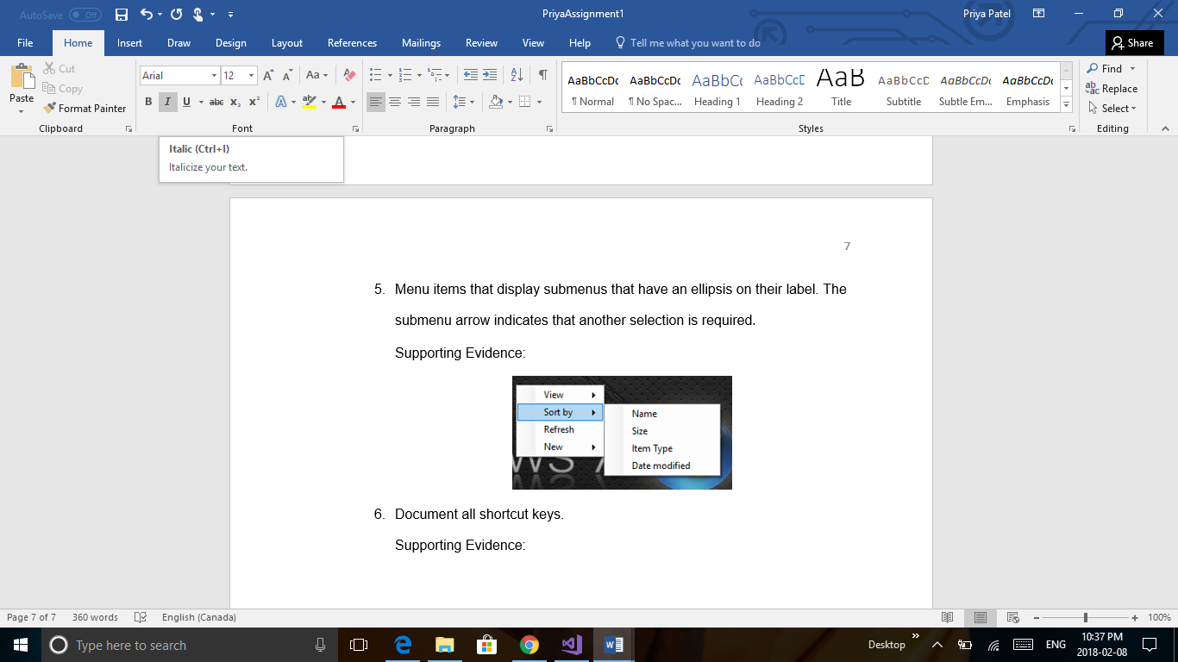

1. Three-dimensional icons are represented in perspective as solid objects, seen from a low bird’s eye view.

Supporting Evidence:



1. Use a contextual tab to display a collection of commands that are relevant only when user select a particular object type.

Supporting Evidence:

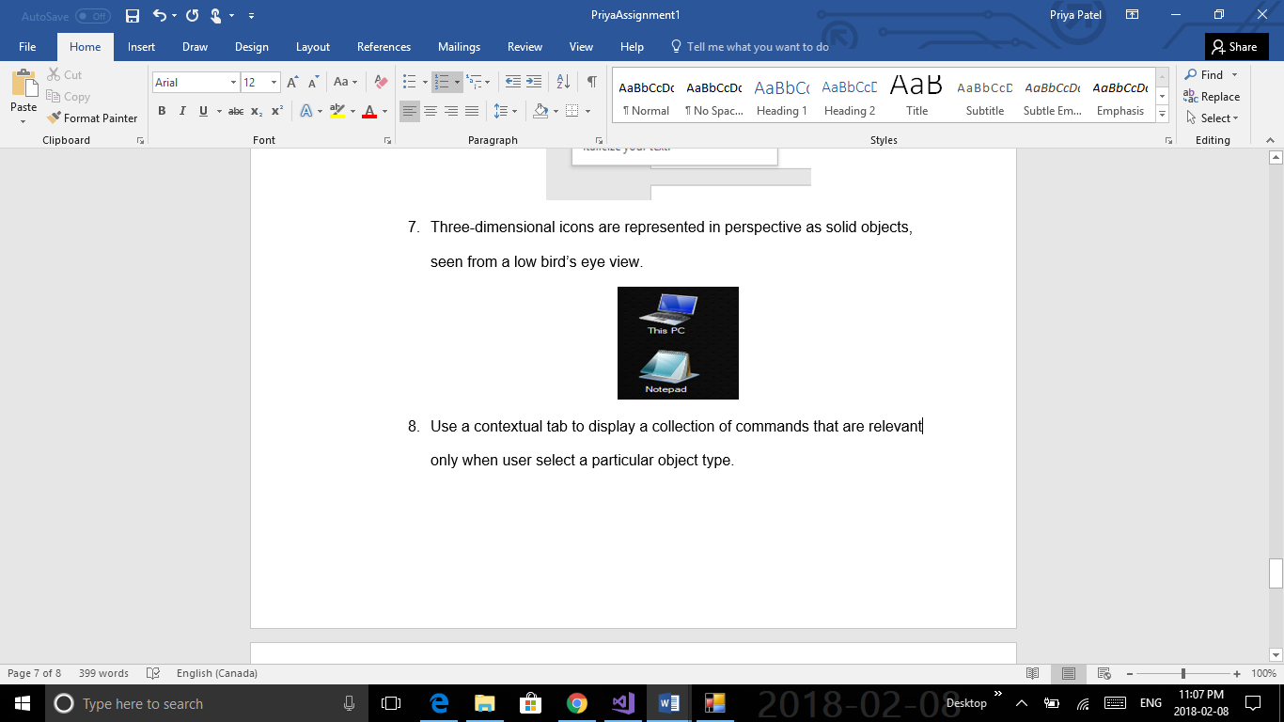

1. Create effective dialog box

Supporting Evidence:

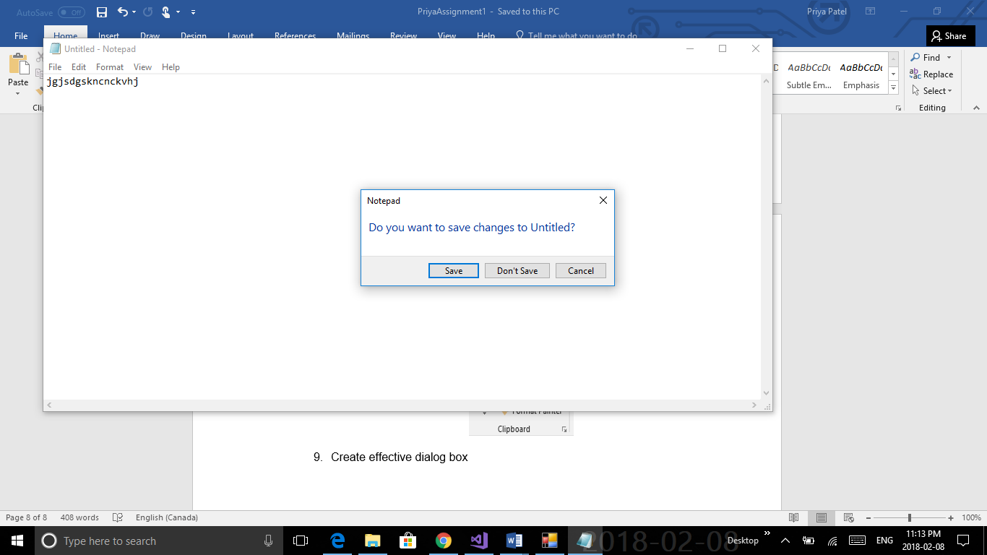

1. Make user friendly interface icon should be self explainatery

Supporting Evidence:

